THE EFFECT OF RISK PERCEPTION ON ATTITUDE, SUBJECTIVE NORM, AND INTENTION TO HOARD FOOD DURING THE COVID-19
PANDEMIC IN SURABAYA

Ansell Cohen Harjono, Margaretha Ardhanari
Universitas Katolik Widya Mandala Surabaya, Jl. Kalisari Selatan No. 1
Email: ansell.cohen.harjono-2024@pasca.unair.ac.id, margaretha@ukwms.ac.id.

Received : 01 October 2025 Published : 03 December 2025
Revised : 15 October 2025 DOI : https://doi.org/10.54443/ijset.v5i1.1402
Accepted : 20 November 2025 Link Publish : https://www.ijset.org/index.php/ijset/index

Abstract
Intention To Hoard Food Is A Desire When Consumers Try To Engage In Food Hoarding Behavior. Intention To Hoard Food Is A Stage Of Consumer Desire In Determining Their Behavior Before Making An Actual Purchase In A Retail Store. Intention To Hoard Food Can Occur Due To Several Things, Including Attitude And Subjective Norms, Which Are Influenced By Risk Perception. The Purpose Of This Study Was To Determine The Effect Of Risk Perception, Attitude, And Subjective Norm On Intention To Hoard Food Among Retail Consumers In Surabaya. The Population Used In This Study Is Retail Consumers In Surabaya. The Sampling Technique Used Quota Sampling With The Conditions That They Were 17 Years Old And Over And Domiciled In Surabaya. The Number Of Samples Studied Was 130 Consumers. The Exogenous Variable In This Study Is Risk Perception. The Endogenous Variables In This Study Were Attitude, Subjective Norm And Intention To Hoard Food. Furthermore, The Authors Processed The Research Data Using Smartpls 3 To Obtain Significant Conclusions Based On The Research Results. Based On The Calculated Hypothesis Testing, The Results Of This Study, Namely Risk Perception, Can Affect Attitude, Subjective Norm And Intention To Hoard Food. Risk Perception Can Also Influence Intention To Hoard Food Through Attitude And Subjective Norms As Mediators.

Keywords: Intetion to Hoard food, Subjective Norm, Attitude, Risk Perception, Consumer Behavior, COVID-19

INTRODUCTION
The global pandemic outbreak of Severe Acute Respiratory Syndrome Coronavirus 2, also known as COVID-19, began on December 31, 2019, in Wuhan, the capital of Hubei Province, in the People's Republic of China. This virus has the ability to transmit viral infections that are highly contagious and mutate rapidly. The structure of COVID-19 is similar to SARS and MERS. The WHO declared a global pandemic emergency on March 11, 2020, after the virus was detected in various countries worldwide, with 4,200 deaths. Various countries also have different attitudes towards actions in responding to the COVID-19 pandemic (WHO, 2020). Currently, every country is developing a national strategy to protect its citizens from contracting the COVID-19 virus. Many countries have been quite successful in suppressing COVID-19 transmission with strict health protocols. At the same time, many business sectors are under pressure due to restrictions, or even shutdowns, of business operations. Without economic activity, the public recognizes a conflict of interest between the economy and health. The longer economic restrictions are in place, the more businesses will be unable to operate. Companies that are not profitable must postpone expansion plans, risking bankruptcy. Economic restrictions have a domino effect on workers' housing, which ultimately reduces consumption, making the brink of recession a real threat for many countries (Long and Khoi, 2020). Indonesia is also a country that has not been spared from COVID-19. Initially, Indonesia was somewhat "late" in its response to COVID-19, while many neighboring countries in the region were already affected by the pandemic. Seven months after the Presidential Palace's announcement, the number of cases in Indonesia has continued to rise. As of October 2, 2020, the number reached 295,499, with 10,972 deaths (John Hopkins University, 2020). As vaccines and cures are still being developed, the government and health authorities are prioritizing short-term policies to monitor the situation. In this situation, the food sector is a crucial area of ​​focus. Consumption is a fundamental requirement for human survival. The suspension of international trade has also disrupted the supply-demand chain. At the same time, people, fearful of the risks of the outbreak, are engaging in massive panic buying. People are hoarding food at various food retailers. Some fearful individuals want to hoard food, but are unable to do so due to inflation or stockouts. This situation only adds to the social pressures that exist (Khan, 2020). Consumer behavior is beginning to shift to embrace a new normal. As people learn to live in new conditions, their ways of thinking and acting will adapt. After several months, various countries have begun to reopen parts of their economies. While the impact of the COVID-19 pandemic has varied, there are five general themes of change within the global consumer market. Consumers are focusing on the essential value of essential goods. Many consumers worldwide are experiencing a decline in income. This situation is forcing consumers to be more mindful of their spending by seeking to consume less expensive products. As consumers face a prolonged period of financial uncertainty, they intend to continue shifting their spending largely to essentials, such as groceries and household supplies, and reducing most discretionary (non-essential) categories.
Next is the shift to omnichannel digitalization of retail. Online sales had been growing since before the pandemic and have continued to grow during this crisis.Most categories have seen over 10 percent growth in their online customer base during the pandemic, and many consumers say they plan to continue shopping online even when brick-and-mortar stores reopen. Beyond e-commerce, digital support services and contactless services have seen significantly higher adoption rates. While some of these habits are seen as a temporary solution to the crisis, they are likely to be adopted long-term. Furthermore, there is a shock to loyalty. Some products and brands are experiencing supply chain disruptions. When consumers can't find their preferred products at their preferred retailers, they change their shopping behavior.
Next comes health and well-being in the economy. In the current climate, many people are choosing shopping locations with visible safety protocols, such as enhanced cleaning and physical barriers. People also prefer products with packaging that appears healthy and hygienic. Some consumers even pay attention to how food producers treat their employees.During these challenging times, consumers are hyperaware of how businesses interact with stakeholders, local communities, and society at large. This is followed by home-based economic activity. Many people are not yet comfortable resuming "normal" activities outside the home. Consumers are adapting their behavior due to the health crisis; easing government restrictions will not be enough. Instead, they will await guidance from medical authorities, assurance that safety measures are in place, and the development of a vaccine and/or treatment for COVID-19 (McKinsey & Company, 2020). This consumer hoarding behavior occurred in various countries simultaneously during the first wave of the COVID-19 outbreak. Some governments implemented nationalist policies, banning food exports. Some countries also implemented food import policies, albeit at high prices amid commodity market speculation. The domino effect of this chaos discouraged individuals in society from taking the risk of supply fluctuations and market prices for their basic necessities. Consumers develop habits over time regarding behavior, including what foods they choose to consume. Consumption behavior is both habitual and contextual.
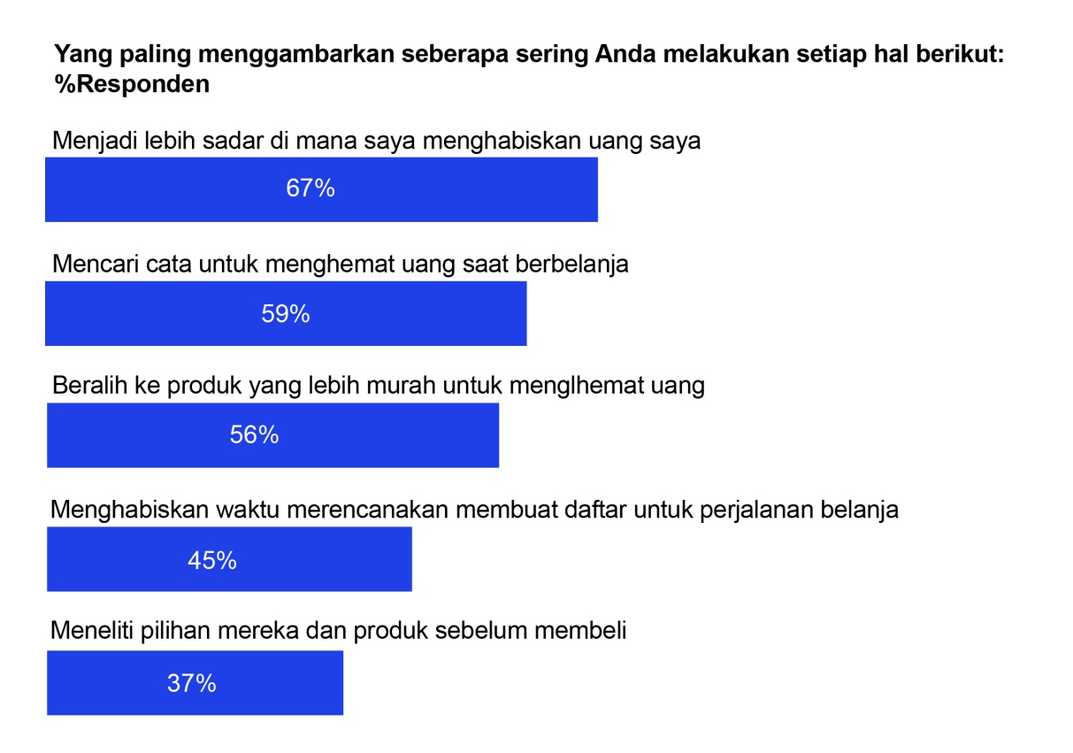
Figure 1.1. Indonesians are becoming more mindful of their spending, leading to the adoption of new habits.
Source: McKinsey & Company (2020)
Based on Figure 1.1, it is clear that Indonesians are becoming more mindful of how they spend their money, leading them to adopt new habits. Regarding the actions taken, it is clear that Indonesians are becoming more mindful of where they spend their money (67 percent), followed by finding new ways to save money when shopping (59 percent), switching to cheaper products to save money (56 percent), taking the time to make a shopping list when shopping (45 percent), and researching brands and products before purchasing (37 percent). This shows that society has changed with the presence of the COVID-19 pandemic as a disruption compared to the previous normal economic order (McKinsey & Company, 2020).
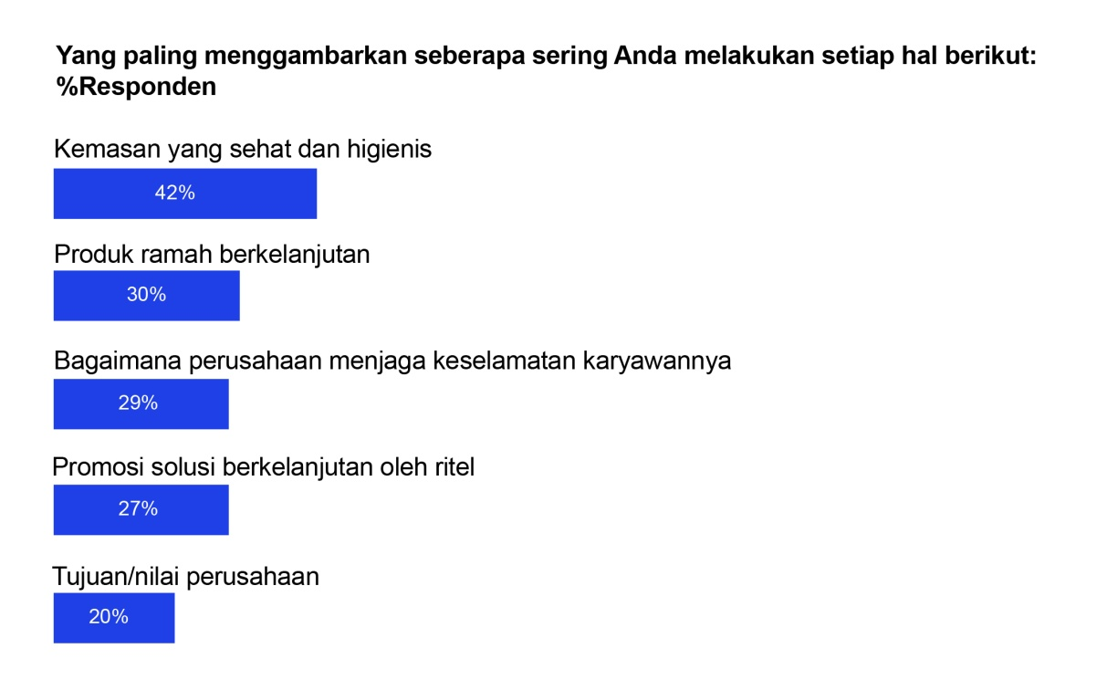
Figure 1.2. Indonesian Society is Increasingly Focused on Packaging and Sustainability
Source: McKinsey & Company (2020)

Based on Figure 1.2, it appears that Indonesians have begun to focus more on packaging and sustainability in their purchasing decisions. Regarding the actions taken, Indonesians base their purchases on health and hygienic packaging (42 percent), followed by sustainable and environmentally friendly products (30 percent), how companies manage employee safety (20 percent), retail promotions of sustainable solutions (27 percent), and company purpose values ​​(20 percent). This indicates that in addition to considering the health and hygiene of products for themselves, consumers are also paying attention to broader long-term impacts (McKinsey & Company, 2020). There are four main contexts that govern changes in consumer behavior. First, changes in the social context through life events such as marriage, having children, and moving from one city to another. Social contexts include the workplace, community, neighbors, and friends. The second context is technology. When technological breakthroughs emerge, old habits are dramatically disrupted. Online searching and ordering have dramatically impacted the way we shop and the products and services we consume. The third context that influences consumption habits is rules and regulations, especially those related to the general public and shared spaces. Public regulations can reduce the social consumption of unhealthy products. Of course, public policy can also influence the consumption of good products and services, such as vaccines for children. The fourth, and less predictable, context is sudden natural disasters such as earthquakes, hurricanes, and global pandemics, including the current Covid-19 pandemic. Similarly, armed conflict, the Great Depression of the late 1920s, and the Great Recession of 2008–2009, all significantly disrupted consumption, production, and supply chains (Sheth, 2020).
In times of crisis, research is needed that analyzes general societal behavior in response to the problems faced. Currently, the crisis requiring research is the impact of the COVID-19 pandemic. Previous research has shown that analyzing individual behavior in uncertain social situations is economically and sociologically important. Van Bavel et al. (2020) suggest that studying social and behavioral sciences can help support the public response to the COVID-19 pandemic. Based on the background of the problem above and previous research conducted by Nguyen and Buy (2020), it can be seen that consumer food purchasing behavior is influenced by factors that shape individual behavior in the face of prevailing social conditions. In a crisis, the government and policymakers can reassure the public appropriately by reassuring individuals in society. Authorities can consider the variables of risk perception (RP), attitude (AT), and subjective norm (SN). The purpose of this research is to determine the impact of the ongoing COVID-19 pandemic on retail consumer behavior in Indonesia. Several changes may occur in consumer behavior as a result of social restrictions, such as lockdowns and social distancing. This study aims to test the impact of risk perception modeling on factors affecting consumer decision-making regarding food purchases using Icek Ajzen's (1967) theory of reasoned action (TRA). This research can provide a theoretical basis for government authorities in identifying risks caused by consumer behavior and the domino effect on the economy, thus providing countries with tools for preparing in designing economic policy options during times of crisis.
There are several differences in the current research withprevious research conducted. The current study is a modification of the research model developed by Nguyen and Buy (2020) which addressed the phenomenon of intention to hoard food at the start of the COVID-19 pandemic, which has been running for half a year now, with different locations, objects, number of respondents, and models. The current study also adjusted the variables used, namely risk perception (RP) to the variables of attitude (AT), subjective norm (SN), and intention to hoard food (IH), referring to the theory of reasoned action (TRA) modeling.
Based on the background of the problem above, the formulation of the problem in this research is as follows:
- Does risk perception influence the attitudes of retail consumers in Surabaya?
- Does risk perception influence the subjective norms of retail consumers in Surabaya?
- Does risk perception influence the intention to hoard food of retail consumers in Surabaya?
- Does attitude influence the intention to hoard food of retail consumers in Surabaya?
- Does subjective norm influence the intention to hoard food of retail consumers in Surabaya?
The following is the writing systematics for the research that will be carried out:
Chapter 1 Introduction
Contains an introduction which includes background, problem formulation, problem objectives, research objectives, research benefits, and writing systematics.
Chapter 2: Theoretical basis
Explains risk perception (RP), attitude (AT), subjective norm (SN), intention to hoard food (IH), previous research, the relationship between risk perception (RP) and attitude (AT), the relationship between risk perception (RP) and subjective norm (SN), the relationship between risk perception (RP) and intention to hoard food (IH), the relationship between attitude (AT) and intention to hoard food (IH), the relationship between subjective norm (SN) and intention to hoard food (IH), and the research model.
Chapter 3: Research methods
Explaining the facts about respondents as research objects, data descriptions, and analysis results and discussions.
Chapter 4: Data analysis and discussion
Explaining the facts about respondents as research objects, data descriptions, and analysis results and discussions.
Chapter 5: Conclusions and suggestions
Contains conclusions, academic suggestions, practical suggestions, and research limitations.

LITERATURE REVIEW AND HYPOTHESIS DEVELOPMENT
Theory of Reasoned Action
The theory of reasoned action was proposed in 1967 by Ajzen to explain the relationship between attitudes and behaviors in human action. Individual decisions about behavior are based on considerations of expectations and available information. The primary goal of the theory of reasoned action is to understand an individual's motivational intentions in performing a behavior. These intentions are determined by two basic variables: attitudes toward behavior and subjective norms. According to Bagozzi, Baungartner, and Yi (1992), the theory of reasoned action is the dominant approach in consumer behavior research. Generally, behavior is operationalized as the observation of individual choices in a free situation. The TRA model posits that attitudes are derived from beliefs about behavior, while subjective norms are derived from normative beliefs. This theory was further developed by Fishbein and Ajzen (1980), explaining that behavior is a function of behavioral intentions and other intervening factors. In other words, behavior is the result of intention and influencing situational factors. Every consumer has a different attitude. This is stated by Peter and Olson (2008:136), who state that each consumer has a different attitude towards a concept. One consumer's attitude can be inconsistent with another consumer's attitude. This statement explains that differences in consumer attitudes can arise from concepts and are inconsistent with each other. However, the intention component is an alternative approach to predicting consumer behavior that is relatively accurate.

Intention to Hoard Food
Ajzen (2005) explains intention as an indication of an individual's readiness to perform a behavior. Intention is a precursor to a behavior that can be measured concretely. Swastha (2008) also adds that intention acts as an intermediary between motivational factors that impact behavior. Behavioral intention can be measured using attitude toward the behavior and subjective norms. Individuals have limited time to translate their intentions into behavior. In measuring intention, there are four main elements: the target goal of the behavior, the action, the situation in which the behavior is performed, and the time the behavior is performed (Ajzen, 2005). Hoarding is defined as an attempt to “accumulate large stocks of personal goods when people perceive a threat to supply” by Sterman and Dogan (2015), making the market possible to create shadow demand. A surge in orders can burden producers and supply chains, and businesses must increase production in the short term under conditions of passive and limited production resources. When the COVID-19 pandemic broke out, health products and commodities became very scarce due to the sudden increase in demand while raw materials and labor were hampered due to the stagnation of the supply chain system to prevent the spread of the disease. According to Nguyen and Buy (2020), the intention to hoard food can be measured using several indicators, namely, the intention to hoard food in the next few days, has planned to hoard food in the next few days, wants to hoard food in the next few days, will hoard food in the next few days.

Attitude
Attitude is a way of thinking or attitude about something, especially as reflected in a person's behavior. Fishbein and Ajzen (1975) suggest that attitude emerges as a variable that influences behavior through a reasoned decision-making process, with a limited impact on three things. First, general attitude does not determine behavior much, but rather behavior by specific attitudes toward a behavior. Second, attitude and subjective norm both have an influence in influencing behavior. Third, attitude and subjective norm together shape the intention to perform a particular behavior. Several researchers have defined attitude. Among them, attitude is defined as an assessment of an individual's beliefs about a behavior. When assessing, a person can make either a positive or negative judgment. Hamdah, Rahmadya, and Nurlaela (2020) suggest that an attitude refers to an individual's attitude toward engaging in a particular behavior. According to the theory, attitude is a function of an individual's underlying beliefs about the outcomes that can be achieved by engaging in a behavior and the value they place on those outcomes. Ajzen (2005) explains that behavioral beliefs are beliefs that underlie attitudes toward a behavior. Behavioral beliefs are a collection of beliefs an individual holds about the positive and negative consequences of engaging in a behavior.
A person can have many beliefs about the consequences of behavior, but only a small portion of these beliefs are used. The theory of reasoned action specifically defines attitude toward behavior as the degree to which a behavioral action is evaluated positively or negatively. Attitude toward behavior is determined by a combination of an individual's beliefs about the positive and/or negative consequences of engaging in a behavior (behavioral beliefs) and the individual's subjective value of each behavioral consequence. It can be concluded that the more positive the consequences of a behavior, the more likely an individual is to adopt a favorable attitude. Conversely, if a behavior is perceived to have a negative impact, an individual will tend to adopt an unfavorable attitude. Ajzen (2005) stated that attitude can be measured using several indicators, namely liking the idea of ​​food hoarding now, food hoarding is a good idea, agreeing with food hoarding now, and being satisfied with the intention to hoard food.

Subjective Norm
Subjective norms are beliefs that are meaningful to an individual or group, allowing individuals to receive support or rejection for certain behaviors. Behavior can be appreciated or punished as a form of approval or disapproval from a particular individual or group. Subjective norms explain how the thoughts of other individuals are needed to demonstrate a behavior. Ajzen (2005) explains that subjective norms are functions based on beliefs called normative beliefs, namely beliefs about the approval or disapproval of a person or group towards a behavior. Ajzen (2005) adds that social references originating from close people such as parents, marriage partners, friends, coworkers, and other references have an impact that is considered important in relation to a behavior. Cialdini and Goldstein (2004); Van Bavel et al. (2020) suggest that people's decisions are influenced by social norms as subjective norms, namely what they perceive others to do or approve or disapprove of.
The theory of reasoned action specifically defines subjective norms as an individual's perception of social pressure regarding whether a behavior is permissible or not. Subjective norms are determined by a combination of individual and group beliefs in defining acceptable and unacceptable behavior. Individuals are motivated to comply with these norms. According to Ajzen (1975), subjective norms in performing a behavior are influenced by the pressure of social forces as motivation to follow. What is meant by other forces are social groups that will respond to the behavior carried out by an individual positively or negatively. Social groups can reward or punish actions taken by an individual. The more an individual's social references support a behavior, the more pressured the individual will tend to participate in the desired behavior. Conversely, the more an individual's social references do not support a behavior, the more pressured the individual will tend to not perform the behavior (Ajzen, 2005). According to Nguyen and Buy (2020), subjective norms can be measured using several indicators, namely, family encouragement for food hoarding, encouragement of close people for food hoarding, encouragement of those who are significant to food hoarding, and family encouragement for food hoarding.

Risk Perception
Humans use their emotions to assess risk, motivate actions, and focus their thinking. This emotional influence is generally helpful, but it can also be harmful (Van Bavel et al., 2020). Initial perceptual reactions to risky situations often diverge from cognitive evaluations and ultimately drive risk perceptions (Loewenstein, Weber, Hsee, and Welch, 2001); Slovic, Finucane, Peters, and MacGregor, 2013); Van Bavel et al., 2020). People rely on their feelings as a substitute for other information, such as the actual numerical risk. In this case, someone who experiences more negative perceptions during a pandemic will perceive greater risk than if they experience less negative emotions (Johnson and Tversky, 1983). Emotions experienced in response to risky situations also influence judgments in two stages (Peters, Lipkus, and Diefenbach, 2006). First, the quality of the emotion (e.g., positive or negative) focuses the decision-maker on relevant information. That information, rather than the feeling itself, is then used to guide judgment. For example, smokers exposed to more emotionally charged health warnings experience more negative emotions toward the warnings and smoking, spend more time examining the warnings, and recall more risks, with subsequent effects on risk perception and quit intentions (Van Bavel et al., 2020).
In the COVID-19 pandemic situation, negative emotions increase. People may seek out and/or consider negative information about COVID-19 more than others. Emotions also act as powerful motivators of behavior (Frijda, 1986), such as social isolation and handwashing, but also hoarding supplies and supporting harsh policies. The function of emotions as direct motivators also means that, with strong perceptual reactions, people often ignore important numerical information such as probability (Rottenstreich and Hsee, 2001), problem scope (Hsee and Rottenstreich, 2004), and time effects (Peters, Kunreuther, Sagara, Slovic, and Schley, 2012); Van Bavel et al. (2020). Risk perception is understood as the extent to which mental recognition perceives factors related to potentially dangerous activities or technologies that determine people's risk assessments (Oltedal, Moen, Klempe, and Rundmo, 2004). The importance of risk perception to the economy has been studied since its inception, dating back hundreds of years to Knight's (2012) study. To date, numerous studies have recognized the impact of risk perception on behavior throughout life, including consumer behavior. Risk level measurement varies with each condition and individual decision-making process is determined by the level of costs, benefits, level of damage, and the level of risk appetite Dowling and Staelin (1994). Risk perception arises when food consumers pay attention to whether consumption is safe or not for physical health before making a decision to purchase a particular product Kozup (2017). According to Dowling and Staelin (1994) stated that risk perception can be measured using several indicators, namely, purchase category risk, perceived benefits, perceived costs.

Hypothesis Development
H1:Risk perception has a positive effect on consumer attitudes.
H2:Risk perception has a positive effect on consumer subjective norms.
H3:Risk perception has a positive effect on consumers' intention to hoard food.
H4:Attitude has a positive influence on consumers' intention to hoard food.
H5:Subjective norms have a positive influence on consumers' intention to hoard food.

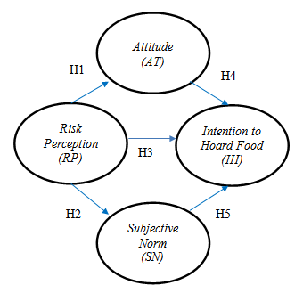
RESEARCH METHODS
In this research, the research method used is a quantitative research method withusing a causal research design. A causal relationship is a cause-and-effect relationship, and includes independent and dependent variables (Sugiyono, 2012:56). This study will analyze the influence of risk perception (RP), attitude (AT), subjective norm (SN), and intention to hoard food (IH) on food retail consumers in Surabaya.

Population and research sample
The population of this study was consumers who had hoarded food after purchasing products and utilizing services provided by retailers in Surabaya. The sample selection method used quota sampling.

Research Variables
The exogenous variable in this study is risk perception. The dependent variables in this study are attitude, subjective norm, and intention to hoard food.

Sampling Techniques
The chosen technique was purposive sampling, which is a technique for selecting samples based on specific considerations. For example, in research on food quality, the data sources would be food experts (Sugiyono 2016: 85). The sample criteria for this study were:
1. Aged 17 years and above.
2. Domiciled in the city of Surabaya.
3. Have you ever done food hoarding?

Data Analysis Techniques
The data analysis technique used by the researcher is PLS (Partial Least Square) which is processed using the SmartPLS 3.0 program. PLS is a powerful analysis method, this PLS method is often referred to as soft modeling because it eliminates OLS (Ordinary Least Square) regression, as the data must be multivariately normally distributed and there is no multicollinearity between exogenous variables (Wold, 1985; in Ghozali, 2015: 5). PLS-SEM consists of 2 sub-models, namely the measurement model which is often referred to as the outer model and the structural model which is often referred to as the inner model. The measurement model shows the manifest variables representing the latent variables to be measured, while the structural model shows the strength of the estimation between the latent variables and the construct variables. (Ghozali, 2015: 7).

results and Discussion

Table 1: Descriptive Test Results
Hypothesis | Influence | Original Sample (O) | t-statistic | P-value
H 1 | Risk Perception -> Attitude | 0.672 | 16,323 | 0,000
H 2 | Risk Perception -> Subjective Norm | 0.737 | 14,844 | 0,000
H 3 | Risk Perception -> Intention to Hoard Food | 0.110 | 1,391 | 0.165
H 4 | Attitude -> Intention to Hoard Food | 0.730 | 8,240 | 0,000
H 5 | Subjective Norm -> Intention to Hoard Food | 0.123 | 1,356 | 0.176

Finding 1
Based on Table 1, it can be seen that the influence of risk perception on attitude obtained a t-statistic value of 16.323 and a p-value of 0.000. This means that risk perception has a significant influence on attitude. In addition, a coefficient of 0.848 (positive) was obtained, this means that risk perception has a positive influence on attitude. Thus, it can be decided that hypothesis 1 is accepted.

Finding 2
Based on Table 1, it can be seen that the influence of risk perception on subjective norm obtained a t-statistic value of 14.844 and a p-value of 0.000. This means that risk perception has a significant influence on subjective norm. In addition, a coefficient of 0.737 (positive) was obtained, this means that risk perception has a positive influence on subjective norm. Thus, it can be decided that hypothesis 2 is accepted.

Finding 3
Based on Table 1, it can be seen that the influence of risk perception on intention to hoard food obtained a t-statistic value of 1.391 and a p-value of 0.165. This means that risk perception does not have a significant influence on intention to hoard food. In addition, a coefficient of 0.760 (positive) was obtained, this means that risk perception has a positive but insignificant influence on intention to hoard food. Thus, it can be decided that hypothesis 3 is rejected. Conversely, if P > 0.05 then there is a probability that the null hypothesis is true, namely that risk perception has no influence on intention to hoard food.

Finding 4
Based on Table 1, it can be seen that the influence of attitude on the intention to hoard food obtained a t-statistic value of 8.240 and a p-value of 0.000. This means that attitude has a significant influence on the intention to hoard food. In addition, a coefficient of 0.720 (positive) was obtained, this means that risk perception has a positive influence on attitude. Thus, it can be decided that hypothesis 4 is accepted.

Finding 5
Based on Table 1, it can be seen that the influence of subjective norms on the intention to hoard food obtained a t-statistic value of 1.536 and a p-value of 0.176. This means that subjective norms do not have a significant influence on the intention to hoard food. In addition, a coefficient of 0.730 (positive) was obtained, this means that risk perception has a positive but insignificant influence on attitude. Thus, it can be decided that hypothesis 5 is rejected. Conversely, if P > 0.05 then there is a probability that the null hypothesis is true, namely subjective norms have no influence on the intention to hoard food.

CONCLUSION
The results obtained from this study can be used as a basis for subsequent research related to the relationship betweenThis study examines consumer risk perception (RP), attitude (AT), subjective norm (SN), and intention to hoard food (IH) during crisis situations. Future research could focus more on examining specific food items and exploring the market conditions. Academics could also continue this research by adding psychological variables that significantly influence individual behavior. Future research should also consider national stability variables, which can influence purchasing intentions from positive to negative, and vice versa. The lack of propaganda in national policies to control crisis situations also deserves further attention. A limitation of this study is the subjectivity of the indicators used to measure food hoarding. Buying more than usual constitutes hoarding. However, the extent of hoarding can vary depending on the type of food being hoarded.

REFERENCES

Abrams, D., Wetherell, M., Cochrane, S., Hogg, M. A., & Turner, J. C. (1990). Knowing what to think by knowing who you are: Self‐categorization and the nature of norm formation, conformity and group polarization. British journal of Social Psychology, 29(2), 97-119.
Ajzen, I. (1985). From intentions to actions: A theory of planned behaviour. From cognition to behaviour (pp. 11–39): Actionocontrol.
______. (1991). The theory of planned behavior. Organizational behavior and human decision processes, 50(2), 179-211.
______. (2011). The theory of planned behaviour: Reactions and reflections. Psychology & Health, 26(9), 1113-1127.
Ajzen, I., & Fishbein, M. (1977). Attitude-behavior relations: A theoretical analysis and review of empirical research. Psychological bulletin, 84(5), 888.
Aldila, N. (2020). Wapres: Masyarakat Tidak Perl Panik Menimbun Makanan. Didapat dari https://kabar24.bisnis.com/read/20200304/15/1208968/wapres-masyarakat-tidak-perlu-panik-menimbun-makanan, 10 Desember 2020, 14:33 WIB.
Araujo, M. J. T. (1985). Theories of export behaviour: a critical analysis. Journal of Marketing, 19(2), 42-52.
Azzahra, T. A. (2020). Ultimatum Polisi ke Para Penimbun Sembako Saat RI Dilanda Corona. Didapat dari https://news.detik.com/berita/d4943922/ultimatum-polisi-ke-para-penimbun-sembako-saat-ri-dilanda-corona, 10 Desember 2020, 14:33 WIB.
Barnett, J., & Breakwell, G. M. (2001). Risk perception and experience: Hazard personality profiles and individual differences. Risk Analysis, 21(1), 171-178.
Baron, R. S., Vandello, J. A., & Brunsman, B. (1996). The forgotten variable in conformity research: Impact of task importance on social influence. Journal of Personality and Social Psychology, 71(5), 915.
Bauer, R. A. (1960). Consumer behavior as risk taking. Chicago, IL, 384-398.
Bikhchandani, S., Hirshleifer, D., & Welch, I. (1998). Learning from the behavior of others: Conformity, fads, and informational cascades. Journal of Economic Perspectives, 12(3),
Bloom, E., De Wit, V., & Carangal-San Jose, M. J. (2005). Potential economic impact of an avian flu pandemic on Asia.
Carr, J. (2020). ‘The madness continues’: Social media users slam ‘wasteful’ panic-buyers who are still throwing away perfectly good food after stockpiling more than they can consume. MAILONLINE. Didapatkan dari https://www.dailymail.co.uk/news/article-8168489/Social-media-users-slam-wasteful-panic-buyers-throwing-away-perfectly-good-food.html
Chen, M.-F., & Tung, P.-J. (2014). Developing an extended theory of planned behavior model to predict consumers’ intention to visit green hotels. International Journal of Hospitality Management, 36, 221-230.
Choi, D., & Johnson, K. K. (2019). Influences of environmental and hedonic motivations on intention to purchase green products: An extension of the theory of planned behavior. Sustainable Production and Consumption, 18, 145-155.
Choi, T.-M., Chiu, C.-H., & Chan, H.-K. (2016). Risk management of logistics systems. Transportation Research Part E: Logistics and Transportation Review, 90, 1–6.
Cialdini, R. B., & Goldstein, N. J. (2004). Social influence: Compliance and conformity. Annu. Rev. Psychol., 55, 591-621.
Conner, M., & Norman, P. (2015). PREDICTING AND CHANGING HEALTH BEHAVIOUR: RESEARCH AND PRACTICE WITH SOCIAL COGNITION MODELS (3rd ed.). Open University Press.
Cooper, M. (2006). Japanese tourism and the SARS epidemic of 2003. Journal of Travel & Tourism Marketing, 19(2-3), 117-131.
Cox, D. F., & Rich, S. U. (1964). Perceived risk and consumer decision-making the case of telephone shopping. Journal of Marketing Research, 1(4), 32-39.
Daellenbach, K., Parkinson, J., & Krisjanous, J. (2018). Just how prepared are you? An application of marketing segmentation and theory of planned behavior for disaster preparation. Journal of Nonprofit & Public Sector Marketing, 30(4), 413-443.
Deng, Y., Wang, M., & Yousefpour, R. (2017). How do people’s perceptions and climatic disaster experiences influence their daily behaviors regarding adaptation to climate change?—A case study among young generations. Science of the total environment, 581, 840-847.
Dickie, R., Rasmussen, S., Cain, R., Williams, L., & MacKay, W. (2018). The effects of perceived social norms on handwashing behaviour in students. Psychology, health & medicine, 23(2), 154-159.
Dowling, G. R., & Staelin, R. (1994). A Model of Perceived Risk and Intended Risk-Handling Activity. Journal of Consumer Research, 21(1), 119.
Fischer, A. R. (2017). Perception of product risks Consumer perception of product risks and benefits (pp. 175-190): Springer.
Fishbein, M., & Ajzen, I. (1975). Belief, Attitude, Intention, and Behavior. A Social Cognitive Theory: Addison-Wesley Reading, MA. -. (1980). Understanding attitudes and predicting social behavior.
Frijda, N. H. (1986). The emotions: Cambridge University Press.
Ghozali, I dan Fuad. 2005. Structural Equation Modeling: Teori, Konsep, dan >>>>>Aplikasi. Semarang: Badan Penerbit Universitas Diponegoro.
Gkargkavouzi, A., Halkos, G., & Matsiori, S. (2019). Environmental behavior in a private sphere context: Integrating theories of planned behavior and value belief norm, self-identity and habit. Resources, Conservation and Recycling, 148, 145-156.
Google News (2020). Coronavirus (COVID-19) (2020). Didapat dari https://news.google.com/covid19/map?hl=enID&mid=%2Fm%2F03ryn&gl=ID&ceid=ID%3Aen
Hair Jr, J. F., Hult, G. T. M., Ringle, C., & Sarstedt, M. (2016). A primer on partial least squares structural equation modeling (PLS-SEM): Sage Publications.
Hamdah, D. F. L., Rahmadya, R. R., & Nurlaela, L. (2020). The Effect of Attitude, Subjective Norm, and Perceived Behavior Control of Taxpayer Compliance of Private Person in Tax Office Garut, Indonesia. Review of Integrative Business and Economics Research, 9, 298-306.
Hansen, T., Møller Jensen, J., & Stubbe Solgaard, H. (2004). Predicting online grocery buying intention: a comparison of the theory of reasoned action and the theory of planned behavior. International Journal of Information Management, 24(6), 539-550.
Henseler, J., Hubona, G., & Ray, P. A. (2016). Using PLS path modeling in new technology research: updated guidelines. Industrial management & data systems, 116(1), 2-20.
Hsee, C. K., & Rottenstreich, Y. (2004). Music, pandas, and muggers: on the affective psychology of value. Journal of Experimental Psychology: General, 133(1), 23.
Hsu, C. H., & Huang, S. (2012). An extension of the theory of planned behavior model for tourists. Journal of Hospitality & Tourism Research, 36(3), 390-417.
Hu, L.-T., & Bentler, P. M. (1998). Fit indices in covariance structure modeling: Sensitivity to underparameterized model misspecification. Psychological methods, 3(4), 424.
Huynh, G., & Nguyen, T. N. H. (2020). Knowledge and attitude toward COVID 19 among healthcare workers at District 2 Hospital, Ho Chi Minh City. Asian Pacific Journal of Tropical Medicine.
Isis, A. A., de Sousa. (2020). Countries Starting to Hoard Food, Threatening Global Trade. Bloomberg.
Jacoby, J., & Kaplan, L. B. (1972). The components of perceived risk. ACR Special Volumes.
Johnson, E. J., & Tversky, A. (1983). Affect, generalization, and the perception of risk. Journal of Personality and Social Psychology, 45(1), 20.
Kaigo, M. (2003). Initial Findings in the Perceptions and Behavioural Change by News on>SARS in Japan. Media Asia, 30(4), 216-219.
Khan, Md Nafiul Alam. “Intention to Reserve Food During COVID-19 Pandemic Among Bangladeshi Internet Users: Based on Theory of Planned Behaviour.” European Journal of Medical and Educational Technologies, vol. 13, no. 2, 2020.
Khoi, B. H., & Long, N. N. (2020). An Empirical Study about the Intention to Hoard Food during COVID-19 Pandemic. Eurasia Journal of Mathematics, Science and Technology Education, 16(7), em1857.
Kisperska-Moroń, D. (1989). The influence of material inventories on materials requirements in Polish engineering industry—Let’s try business logistics. Engineering Costs and Production Economics, 15, 75-79.
Kitchenham, B. A., & Pfleeger, S. L. (2002). Principles of survey research: part 3: constructing a survey instrument. ACM SIGSOFT Software Engineering Notes, 27(2), 20-24.
Klesel, M., Schuberth, F., Henseler, J., & Niehaves, B. (2019). A test for multigroup comparison using partial least squares path modeling. Internet research, 29(3), 464-477.
Knight, F. H. (2012). Risk, uncertainty and profit: Courier Corporation.
Kozup, J. (2017). Risks of Consumer Products Consumer Perception of Product Risks and Benefits (pp. 23-38): Springer.
Kuo, H.-I., Chen, C.-C., Tseng, W.-C., Ju, L.-F., & Huang, B.-W. (2008). Assessing impacts of SARS and Avian Flu on international tourism demand to Asia. Tourism Management, 29(5), 917-928.
Laato, S., Islam, A. N., Farooq, A., & Dhir, A. (2020). Unusual purchasing behavior during the early stages of the COVID-19 pandemic: The stimulus-organism-response approach. Journal of Retailing and Consumer Services, 57, 102224.
Lai, C.-C., Shih, T.-P., Ko, W.-C., Tang, H.-J., & Hsueh, P.-R. (2020). Severe acute respiratory syndrome coronavirus 2 (COVID-19) and corona virus disease-2019 (COVID-19): the epidemic and the challenges. International journal of Antimicrobial Agents, 105924.
Lee, M.-C. (2009). Factors influencing the adoption of internet banking: An integration of TAM and TPB with perceived risk and perceived benefit. Electronic Commerce Research and Applications, 8(3), 130-141.
Limayem, M., Hirt, S. G., & Cheung, C. M. (2007). How habit limits the predictive power of intention: The case of information systems continuance. MIS quarterly, 705-737.
Li, J., Hallsworth, A. G., & Coca‐Stefaniak, J. A. (2020). Changing Grocery Shopping Behaviours Among Chinese Consumers At The Outset Of The COVID‐19 Outbreak. Tijdschrift Voor Economische En Sociale Geografie, 111(3), 574-583.
Lo, A. Y. (2013). The role of social norms in climate adaptation: Mediating risk perception and flood insurance purchase. Global Environmental Change, 23(5), 1249-1257.
Lobb, A., Mazzocchi, M., & Traill, W. (2007). Modelling risk perception and trust in food safety information within the theory of planned behaviour. Food quality and preference, 18(2), 384-395.
Loewenstein, G. F., Weber, E. U., Hsee, C. K., & Welch, N. (2001). Risk as feelings. Psychological bulletin, 127(2), 267.
Lohmöller, J.-B. (2013). Latent variable path modeling with partial least squares: Springer Science & Business Media.
López-Mosquera, N., & Sánchez, M. (2012). Theory of Planned Behavior and the Value Belief Norm Theory explaining willingness to pay for a suburban park. Journal of Environmental Management, 113, 251-262.
__________________. (2020). Consumer sentiment and behavior continue to reflect the uncertainty of the COVID-19 crisis (2020). Didapat dari https://www.mckinsey.com/business-functions/marketing-and-sales/our-insights/a-global-view-of-how-consumer-behavior-is-changing-amid-covid-19#
__________________. (2020). Survey: Food retail in Indonesia during the COVID-19 Pandemic (2020). Didapat dari https://www.mckinsey.com/industries/retail/our-insights/survey-food-retail-in-indonesia-during-the-covid-19-pandemic
__________________. (2020). Survey: Indonesian consumer sentiment during the coronavirus crisis (2020). Didapat dari https://www.mckinsey.com/business-functions/marketing-and-sales/our-insights/survey-indonesian-consumer-sentiment-during-the-coronavirus-crisis
Mimiaga, M. J., Reisner, S. L., Reilly, L., Soroudi, N., & Safren, S. A. (2009). Individual interventions HIV Prevention (pp. 203-239): Elsevier.
Mitchell, V. W. (1999). Consumer perceived risk: conceptualisations and models. European Journal of Marketing, 33(1/2), 163–195.
Sheth, J. (2020). Impact of Covid-19 on consumer behavior: Will the old habits return or die? Journal of Business Research, 117, 280–283.
Supriyatna, I. (2020). Jangan Takut Corona, Pengusaha Jamin Pasokan Makanan Aman Hingga Lebaran. Didapat dari https://www.suara.com/bisnis/2020/03/12/143450/jangan-takut-corona-pengusaha-jamin-pasokan-makanan-aman-hingga-lebaran, 10 Desember 2020, 14:33 WIB.
Taufiq, R. (2020). Pemerintah Surabaya Jamin Pasokan Makanan Aman. Didapat https://nasional.tempo.co/read/134167/pemerintah-surabaya-jamin-pasokan-makanan-aman, 10 Desember 2020, 14:33 WIB.
Widiyani, R. (2020). Ultimatum Fatwa MUI: Timbun Masker dan Sembako saat Ada Virus Corona Hukumnya Haram. Didapat dari https://news.detik.com/berita/d-4941771/fatwa-mui-timbun-masker-dan-sembako-saat-ada-virus-corona-hukumnya-haram, 10 Desember 2020, 14:33 WIB.
World Health Organization. (2020). Archived: WHO Timeline – COVID-19 (2020). Didapat dari https://www.who.int/news-room/detail/27-04-2020-who-timeline---covid-19
Zwanka, R. J., & Buff, C. (2020). COVID-19 Generation: A Conceptual Framework of the Consumer Behavioral Shifts to Be Caused by the COVID-19 Pandemic. Journal of International Consumer Marketing, 1-10.

